**LAB CYCLE 1**

**Submitted by**

**SIJI JOSE**

**MCA135**

**LAB CYCLE 1 – QUESTION 1**

**AIM:** Model a simple HTML file to demonstrate the use of different tags.

**PROGRAM CODE**:

<html>

<head>

<title>

A Simple HTML Document

</title>

</head>

<body>

<p>This is a very simple HTML document</p>

<p>It only has two paragraphs</p>

</body>

</html>

**RESULT:**

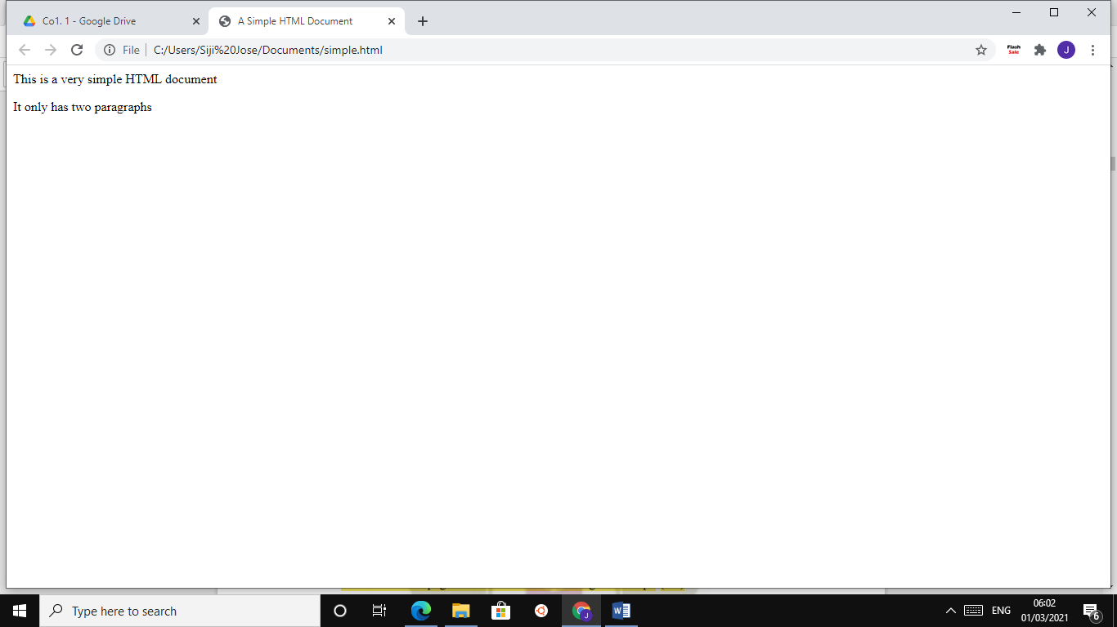

**LAB CYCLE 1-QUESTION 2**

**AIM:** Create a HTML file to link to different HTML page which contains images, tables, and also link within a page.

**PROGRAM CODE:**

<!DOCTYPE html>

<html>

<head>

<title>map-india</title>

</head>

<body>

<img src="https://images-na.ssl-imagesamazon.com/images/I/71RgfIeTq6L._SX569_.jpg" usemap="#india">

<map name="india">

<area shape="circle" coords="152,562,10"

href="https://en.wikipedia.org/wiki/Kerala"><a

href="https://en.wikipedia.org/wiki/Kerala">Kerala</a>

<area shape="circle" coords="194,550,15"

href="https://en.wikipedia.org/wiki/Tamil_Nadu"><a

href="https://en.wikipedia.org/wiki/Tamil_Nadu">Tamil Nadu</a>

<area shape="circle" coords="143,465,15"

href="https://en.wikipedia.org/wiki/Karnataka"><a

href="https://en.wikipedia.org/wiki/Karnataka">Karnataka</a>

<area shape="circle" coords="202,303,30"

href="https://en.wikipedia.org/wiki/Madhya_Pradesh"><a

href="https://en.wikipedia.org/wiki/Madhya_Pradesh">Madhya Pradesh</a>

</map>

</body>

</html>

**RESULT:**

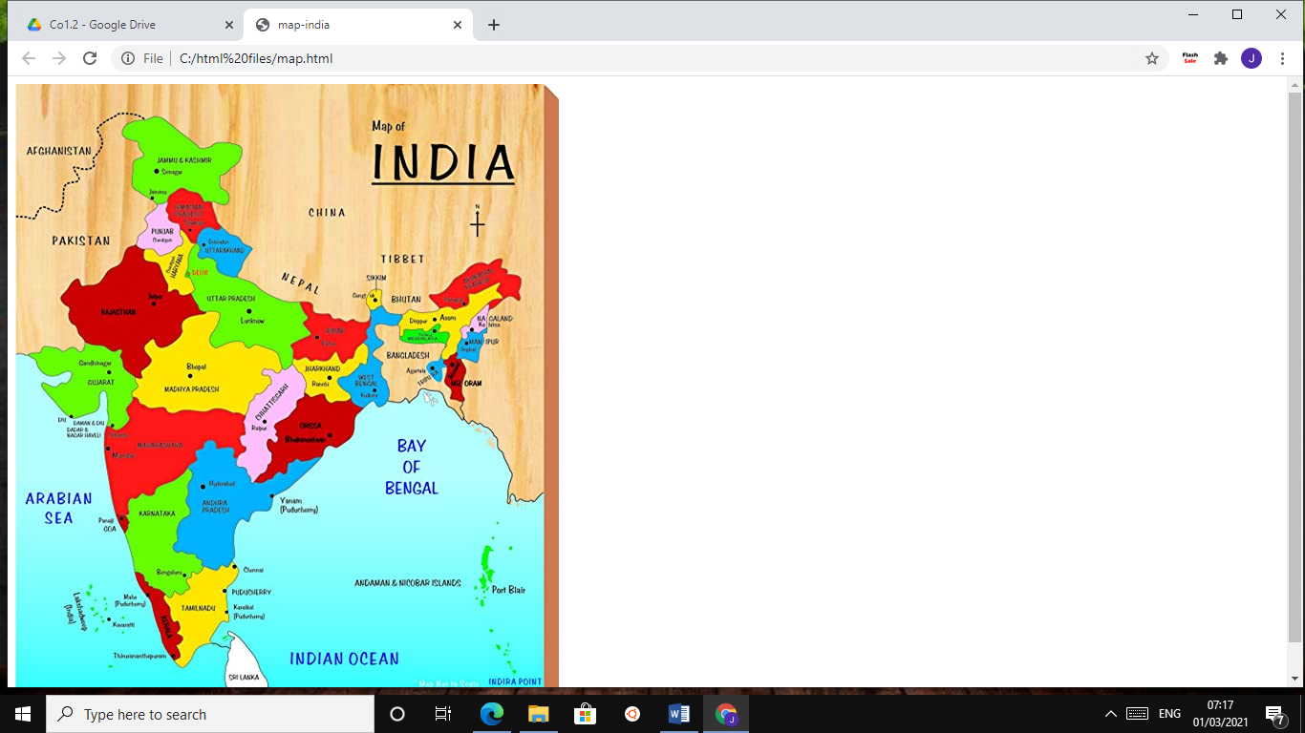

**LAB CYCLE 1- QUESTION 3**

**AIM:** Create a HTML page with different types of frames such as floating frame, navigation frame & mixed frame.

**PROGRAM CODE:**

* *sijijose.html*

<!DOCTYPE html>

<html>

<head>

<meta name="viewport"

content="width=device-width, initial-scale=1">

<style>

body{

margin:0;

font-family: Arial, Helvetica,sans-serif;

}

.topnav {

overflow: hidden;

background-color:#333;

}

.topnav a {

float: left;

color: #f2f2f2;

text-align: center;

padding: 14px 16px;

text-decoration: none;

font-size: 17px;

}

.topnav a:hover {

background-color: #4cAF50;

color: white;

}

</style>

<title>SIJI JOSE</title>

</head>

<body style="background:url(

https://i.pinimg.com/originals/c4/d2/e5/c4d2e5787b567ea31a2eb410159505

3d.jpg);">

<body>

<div class="topnav">

<a class="active" href="sijijose.html"> Home </a>

<a href="academic.html"> Academics </a>

<a href="contact.html"> Contact </a>

</div>

<div style="padding-left:16px">

<br>

<h2> Hello, I'm <strong>SIJI</strong>...</h2>

</br>

<p>A student of MCA at <strong>TKM COLLEGE OF

ENIGNEERING,KOLLAM</strong></p>

<p><strong>MCA</strong> is a job-oriented course that hepls students,

a career in IT field. It helps in preparing to jump in the industry as

system designers,programmers,etc.</p>

<p>If you are looking for such a job, TKMCE is a best option for

you.The Institution is affiliated to the APJ Abdul Kalam Technological

University, and all the programmes offered in the college are approved

by the All India.</p>

<p> Those who wish to get admission and to know more about college

can contact me or <a href="https://www.tkmce.ac.in"> visit</a> the

website</p>

</body>

</html>

* *contact.html*

<!DOCTYPE html>

<contact.html>

<meta name="viewport"

content="width=device-width, initial-scale=1">

<style>

body{

margin:0;

font-family: Arial, Helvetica,sans-serif;

}

.topnav {

overflow: hidden;

background-color:#333;

}

.topnav a {

float: left;

color: #f2f2f2;

text-align: center;

padding: 14px 16px;

text-decoration: none;

font-size: 17px;

}

.topnav a:hover {

background-color: #4cAF50;

color: white;

}

</style>

<title>contact.SIJI JOSE</title>

<body style="background:url(

https://i.pinimg.com/originals/c4/d2/e5/c4d2e5787b567ea31a2eb410159505

3d.jpg);">

<body>

<div class="topnav">

<a class="active" href="sijijose.html"> Home </a>

<a href="academic.html"> Academics </a>

<a href="contact.html"> Contact </a>

</div>

<br>

<header>

<strong> CONTACT ME </strong>

</header>

<table>

<p>Phone : 7994109268</P>

<p>Email : sijijose.sj1999@gmail.com</p>

<p>Address : Jose Bhavanam,Mathilil,Kollam,691601.</p>

</table>

</br>

</body>

</contact.html>

* *academic.html*

<!DOCTYPE html>

<academic.html>

<meta name="viewport"

content="width=device-width, initial-scale=1">

<style>

body{

margin:0;

font-family: Arial, Helvetica,sans-serif;

}

.topnav {

overflow: hidden;

background-color:#333;

}

.topnav a {

float: left;

color: #f2f2f2;

text-align: center;

padding: 14px 16px;

text-decoration: none;

font-size: 17px;

}

.topnav a:hover {

background-color: #4cAF50;

color: white;

}

</style>

<title>academic.SIJI JOSE</title>

<div class="topnav">

<a class="active" href="sijijose.html"> Home </a>

<a href="academic.html"> Academics </a>

<a href="contact.html"> Contact </a>

</div>

<header> <strong>ACADEMIC DETAILS</strong> </header>

<body style="background:url(

https://i.pinimg.com/originals/c4/d2/e5/c4d2e5787b567ea31a2eb410159505

3d.jpg);">

<body>

<table border = "1">

<tr>

<th>COURSE</th>

<th>SCHOOL/COLLEGE</th>

<th>YEAR OF PASSING</th>

<th>PERCENTAGE</th>

</tr>

<tr>

<td>DEGREE</td>

<td>FATIMA MATA NATIONAL COLLEGE, KOLLAM</td>

<td>2020</td>

<td>86</td>

</tr>

<tr>

<td>HSE</td>

<td>GHSS.ANCHALUMMODU,KOLLAM</td>

<td>2017</td>

<td>92</td>

</tr>

<tr>

<td>SSLC</td>

<td>VIMALA HRIDAYA ,KOLLAM</td>

<td>2015</td>

<td>98</td>

</tr>

</table>

</body>

</academic.html>

**RESULT:**

* sijijose.html

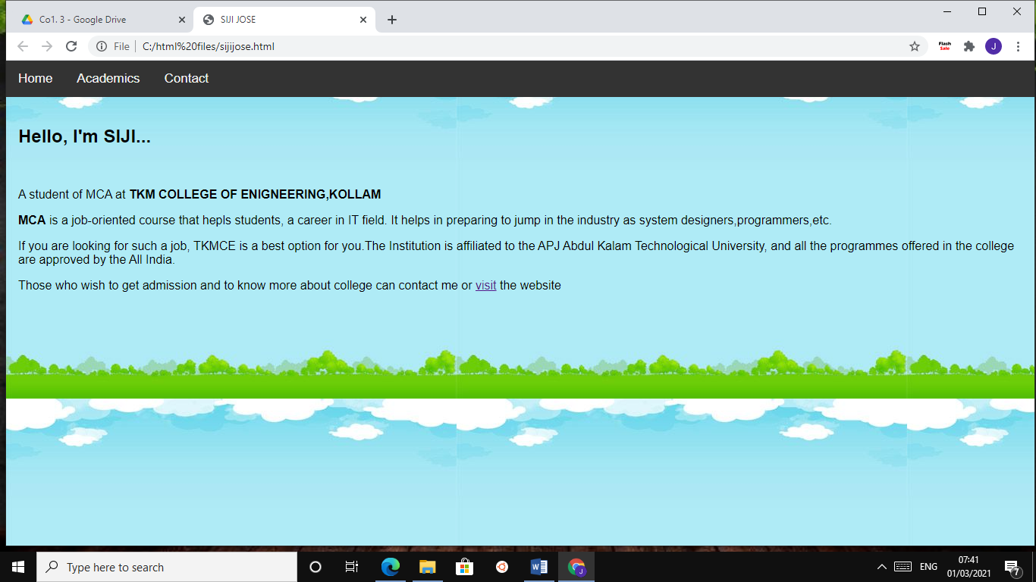

* contact.html

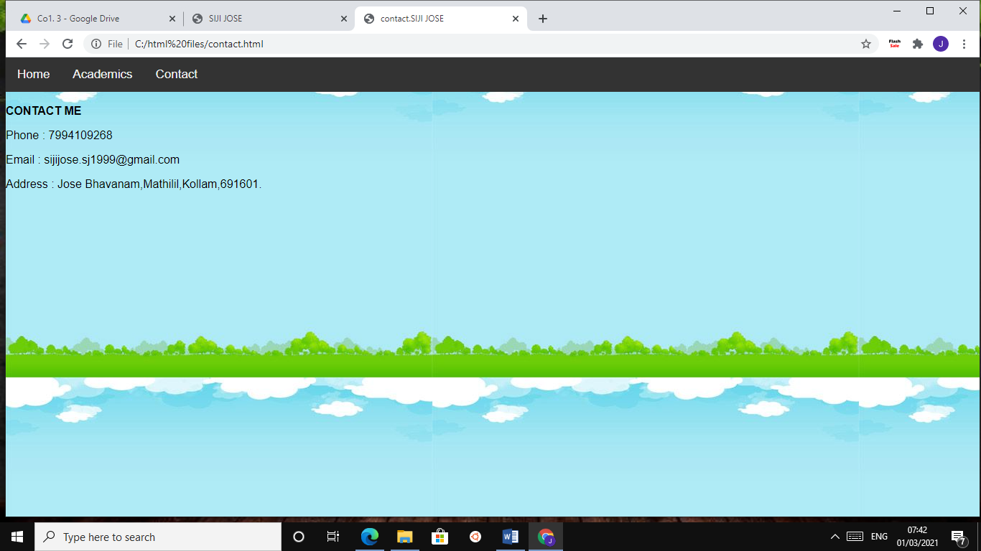

* academic.html

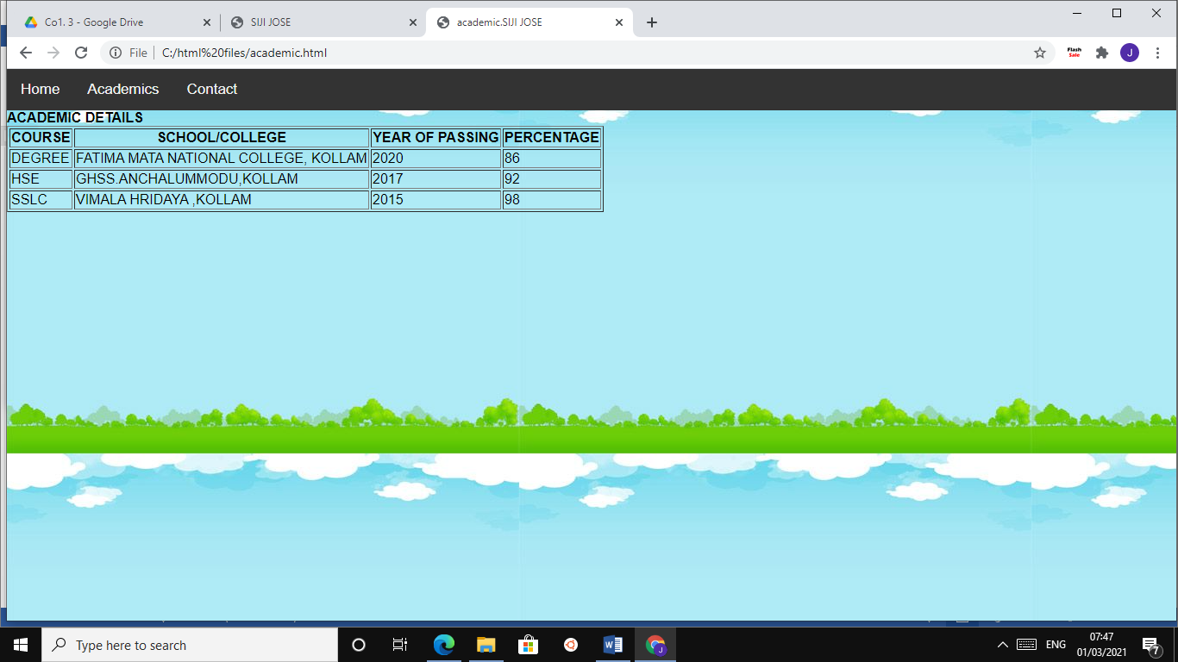

**LAB CYCLE 1-QUESTION 4**

**AIM:** Analyze CSS by applying the different styles using inline, external & internal style sheets in a HTML file.

**PROGRAM CODE:**

* *INLINE*

<!DOCTYPE html>

<html>

<body style="background-color:yellow;font-family:'sans-serif'">

<h1 style="color:white;background-color:green;textalign:center">INLINE CSS<h1>

<p style="color:red;font-size:25px">An inline CSS is used to apply a

unique style to a single HTML element.An inline CSS uses the style

attribute of an HTML element.</p>

</body>

</html>

* *INTERNAL*

<html>

<head>

<style>

body{

background-color:yellowgreen;

font-family:'arial';

}

p{

color:blue;

font-size:20px;

}

h1{

color:red;

background-color:yellow;

text-align:center;

}

</style>

</head>

<body>

<h1>INTERNAL CSS</h1>

<p>An internal CSS is used to define a style for a single HTML page.</p>

</body>

</html>

* *EXTERNAL*

<html>

<head>

<link type="text/css" rel="stylesheet" href="style.css">

</head>

<body>

<h1>INTERNAL CSS</h1>

<p>An internal CSS is used to define a style for a single HTML page.</p>

</body>

</html>

**RESULT:**

* *Inline.html*

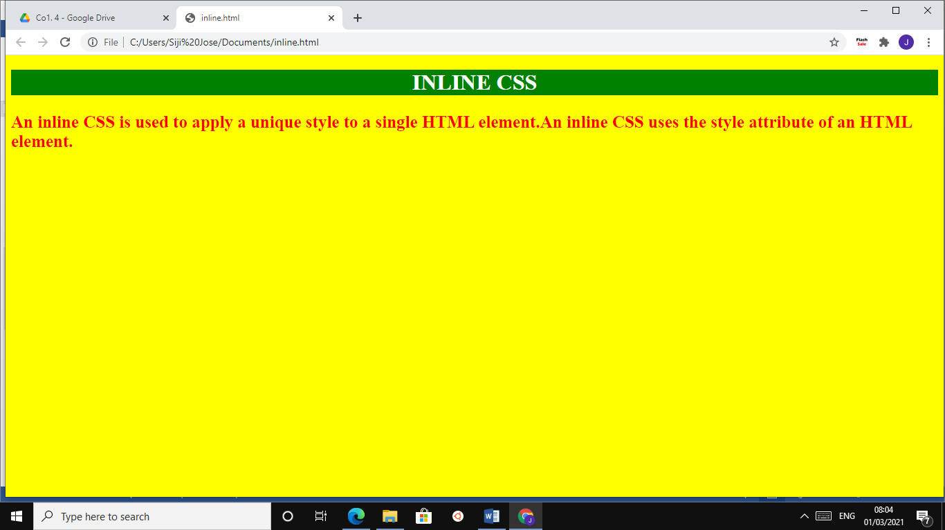

* *Internal.html*

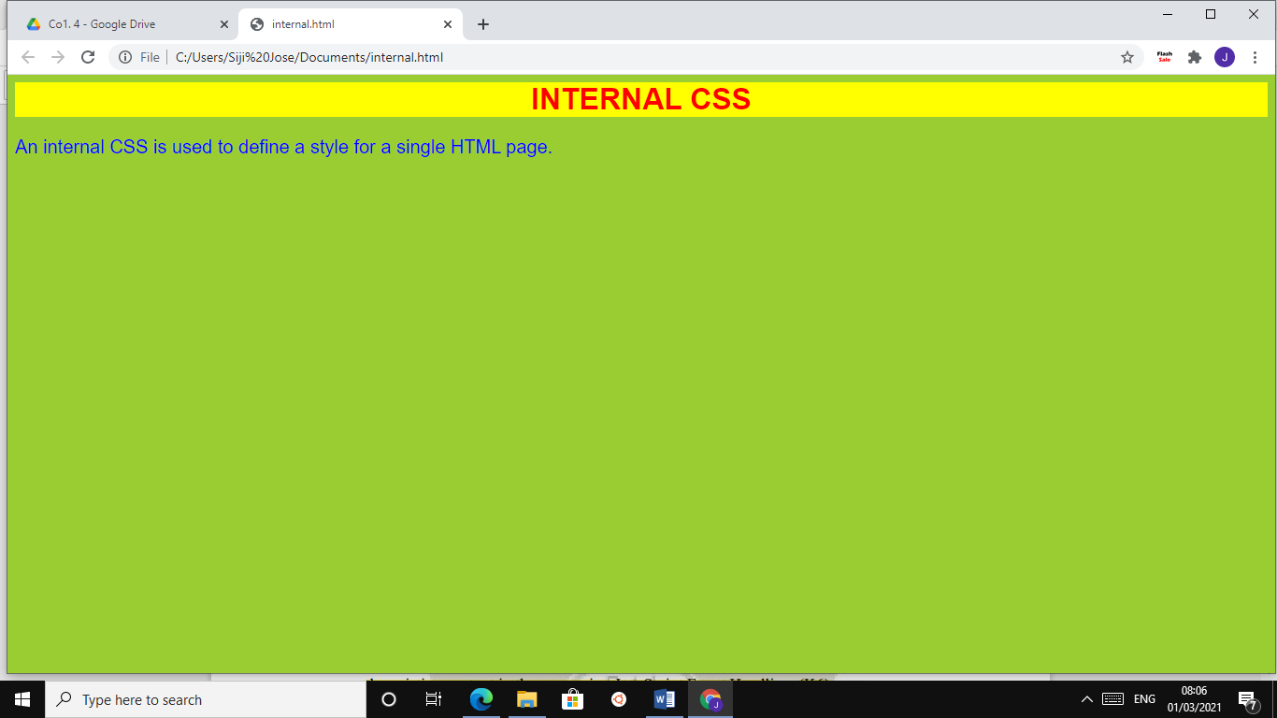

* *External.html*

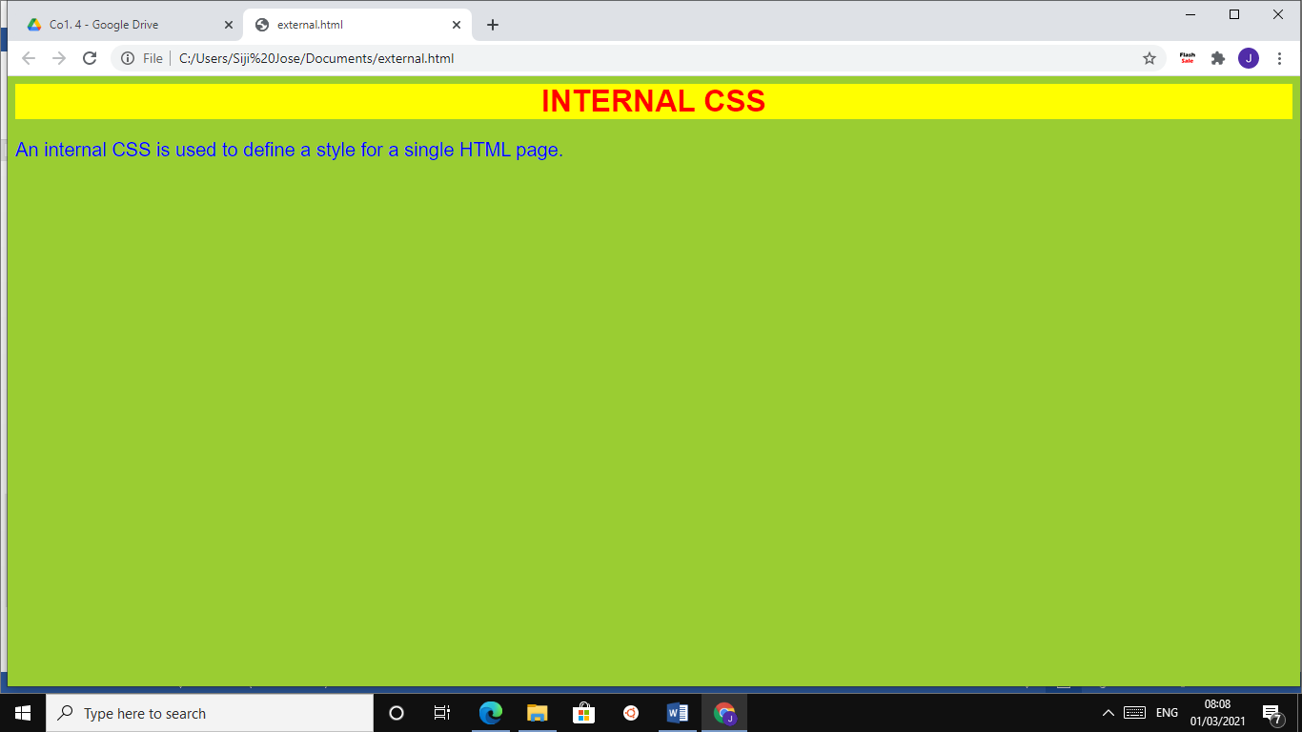

**LAB CYCLE 1-QUESTION 5**

**AIM:** Demonstrate a registration form using HTML.

**PROGRAM CODE:**

<!DOCTYPE html>

<html>

<head>

<center><h1> ENTRY FORM </h1></center>

</head>

<body bgcolor="blue">

<br>

<form>

<label> NAME : </label>

<input type ="text" name="name" size="15"/>

<br>

<label> EMAIL : </label>

<input type="email" id="email" name="email"/>

<br>

<label> ADDRESS : </label><br>

<textarea cols="80" rows="5" value="address">

</textarea>

</br>

<label> GENDER : </label><br>

<input type="radio" name="male"/>Male<br>

<input type="radio" name="female"/>Female<br>

<input type="radio" name="other"/>Other<br>

<input type=reset value="Reset">

<input type=submit value="submit">

</form>

</body>

</html>

**RESULT:**

